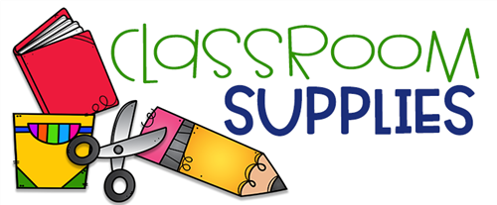
2023-2024 Supply List

ALL STUDENTS:

- Eight (8) rolls of paper towels; (Costco or Bounty preferably for its absorbency)
- 2 boxes of Kleenex.
- A box of gallon-sized Ziploc bags. (Not with the zippered tab)
- 5 large Elmer’s washable disappearing purple glue sticks. (Little Foots should purchase the smaller, shorter glue sticks.)
- A change of clothing, each piece labeled with the child’s name; placed in a Ziploc bag. (Little Foots/Toddlers will need 2 sets)
- A nutritious and well-balanced lunch and drink for the child daily. We will no longer re-heat lunches or prep food (ramen, mac & cheese etc.) The parent shall also pack a simple daily morning AND afternoon snack for their child. Any food item left over from meals/snacks will be discarded daily.
- AN APPROPRIATE-SIZED, LIGHTWEIGHT blanket (Please, NO SLEEPING BAGS) labeled with the child’s name, as our cubby space is limited. (Full-time and Extended Day students only.) Licensing guidelines have suggested daily cleaning of sleeping material during this crisis~ please plan to gather by remembering to take home daily. Our sleeping cots are sanitized daily. (ALL sleeping materials are sent home every Friday)
- A water bottle to keep in school during the week. Child should bring in on Monday and take home on Friday. No large Hydro Flasks please!!
- Five (5) disposable face masks to replenish their supply if needed.

Additional supplies needed for the following age groups:

- Children enrolled in our “Toddler” program shall initially supply pull-ups and 2 pkgs. of wipes. Supply shall be replenished throughout the year upon our request. For ease in diaper changing, we ask that girls refrain from wearing tights and boys should have elastic-waist pants or shorts.
- Children enrolled in our “Big Birds”/Pre-K Program will need to bring 2 large pink erasers.
Mahalo for your cooperation!!

