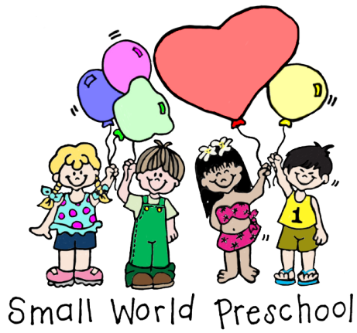®
October 4, 2021

UPDATED
Small World COVID-19 School Policies
(Adapted from: Covid-19 School and Community Commitment Agreement)

10-4-21 Updates are in Blue/ 11-5-21 Update in Green

Small World Preschool’s In-School’s Safety Measures:
Our goal is to minimize outside exposures and continue to practice all precautionary measures so that the quality of the learning experience for your child remains intact. It is our practice to:
- Perform daily temperature checks upon entry to school.
- Teach the children proper handwashing, hygiene routines and techniques.
- Implement social distancing practices.
- Wear face masks that cover both the nose and mouth. Because of the level of physical exertion and difficulty to constantly monitor and control physical distance between the children, outdoor play will require the wearing of a mask. They will remove their masks at mealtime and naptime only.
- Use gloves when appropriate.
- Frequently clean and disinfect throughout the school day; especially on high-touch surfaces.
- Deep clean and disinfect the school facility and environment at the end of the school day and again prior to school opening.
- Non-essential visitors not permitted entry.
- School observations by appointment only; and tour time will be limited. Visitor(s) will be screened at entry and must wear a mask.

Family’s At-Home Safety Measures:
- All members of household shall commit to all precautionary measures to ensure a healthy home environment. We agree to:
- Monitor for any symptoms, self-quarantine if any chance of exposure occurs.
- Sanitize and disinfect home environment.
- Model hand-washing habits by promoting awareness and helping your child identify when hand washing is necessary.
- Wear face masks according to local mandates and guidelines.
- Disclose any confirmed diagnosis within immediate family or exposure to someone outside the home that has been diagnosed with Covid-19.
- Limit/avoid exposure to groups larger than 10 people (outside of immediate family). Avoid large crowds when possible.
If Your Child is Sent Home Sick:
- If your child is sent home from school after school has started due to Covid-type symptoms, please keep them home for a minimum of 1 (one) day; monitor them for any symptom (no matter how small), and get them screened for Covid-19 if their symptoms continue or do not get better.

- If your child is out sick due to any symptom, we are also requiring a negative PCR Covid test prior to returning to school. With the Delta variant and the cases involving younger children that are not eligible to receive the vaccination on the rise, we concluded that stricter preventive measures need to be in place to protect our vulnerable keiki.
Even if your child receives a negative Covid result, we are asking that you keep them home until they are 100% as they may just be experiencing a common cold or virus, to avoid us having to call you to pick them up from school.

Regarding Travel (both domestically and internationally; any family or visitors):
Be advised that due to ever-changing guidelines, our policy may change at any given time.

- The preschool will require the documentation of the following for the child to return to school:
- Parent/Guardian: Completed Covid-19 vaccination series (card must be presented to school). Travel must not have occurred for a minimum of 2 weeks after completing the recommended series of doses. You are not considered fully vaccinated until you complete the requirements. Because you are still able to transmit the virus even after receiving the vaccinations, you should continue to self-monitor thoroughly.
- Completion of the destination’s safe-travel requirements (pre and/or post-testing) with negative results. This must also be documented and presented to the school to return.
- In the event of family visiting the child’s home, the visitor(s) must also adhere to Items 1 and 2 for the child to return to school. It is also expected and assumed that the adult members are also fully vaccinated.
- Whenever there is a visitor (domestic and international), the child will have to remain out of school and proceed to get tested for Covid after a minimum of 3 days of being exposed to the traveler in question before they can return to school. Results will need to be emailed to school prior to re-entry. This requirement also includes if the traveler is vaccinated and received a negative test pre or post arrival to Hawaii Island.
- Should you and any member of the adult household find themselves unable to adhere to any of the following above, the child will be expected to quarantine at home for 10 days.
- Completion of the Covid 19 Disclosure form sent out acknowledging that the child/family has not experienced Covid-19 symptoms for 10 days prior to return to school.
- There are no exceptions to the above.

