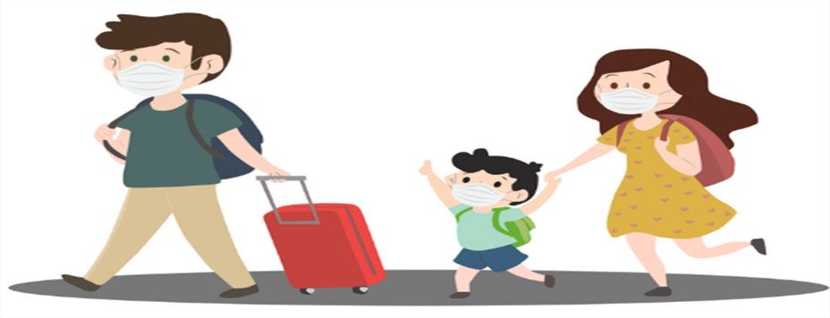
Travel Guidelines/Requirements to Be Able to Return to School Effective Immediately:

We felt the necessity to take a pro-active stance due to the recent increase in case counts here and on the mainland. As such, to clarify policy with regards to travel and exposure to someone that has traveled, we have enacted the following:

- Students that interact with mainland/overseas* visitors will be required to get a Covid-19 test with negative results BEFORE they can return to school (regardless of the negative result that the visitor may receive from the 72 hour pre-test.) The child’s results shall be presented to school prior to entry. If you choose not to have the child take a COVID-19 test, they will be required to stay out of school for the 14-day quarantine period.
- Tests will need to be taken from a state-approved lab or pharmacy.

The preschool feels it would be in everyone’s best interests to be pro-active with regards to Covid-19 by taking these additional precautions; especially with the holidays approaching, re-opening of trans-pacific travel, and the apparent lack of social distancing practices in our island-wide communities as shown by the recent surge in cases. We appreciate your understanding with this matter and expect honesty and adherence.

*May also involve interisland travel as we are closely monitoring their case counts. In the meantime, we urge you to be diligent ~ wearing masks that fit properly, practicing social distancing, and monitoring of any onset of symptoms.

